 

**18-Hole Scramble Food & Awards**

**www.centrevillefair.com**

**All Proceeds Go Towards Premium Fund**

**9:00am Shotgun Start**

Gator Raffle

or $4,500

Drawing to be held September 26, 2015 at 4pm

In front of the Fair Office below the Grandstand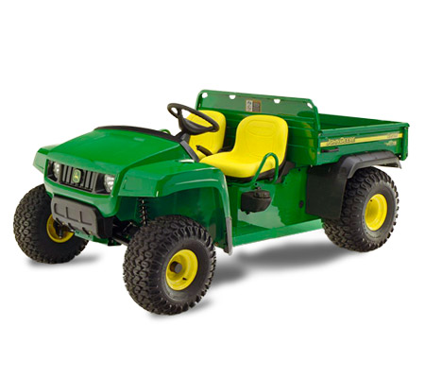

$5 Ticket or 5 for $20

All proceeds will go to premium fund



Partners with Sauganash Golf Club

Monday July 13, 2015

Contact Name: ______________________________________________________________________  
Player(s) Name(s): ____________________________________________________________________  
 ______________________________________________________________________  
Company Name: _____________________________________________________________________

Address: ____________________________________________________________________________

City/State/Zip: _______________________________________________________________________

Phone/Fax/Email: ____________________________________________________________________

* **The check enclosed is payable to St. Joseph County Fair, PO Box 578, Centreville, MI 49032**
* **Please charge my VISA, MasterCard, or Discover**

Signature: ___________________________________________________________________________

Card # _____________________________________ Expiration: __________Security Code_______

*For more information or to register, call St. Joseph County Grange Fair at 269.467.8935*

Tee or Hole Sponsor:   
$100 (All Tax Deductible)  
Includes: Sign & Program Mention  
(Please provide a logo and   
company name as it should appear)

$160/Team of Four  
or $40.00/Player  
Includes:   
Green Fees & Cart, Lunch, and Awards