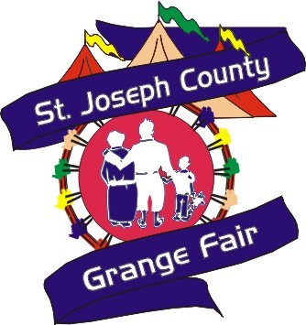

FIRE UP YOUR FAVORITE CLASSIC CAR, TRUCK,

HOT ROD OR ANTIQUE

AND PARTY LIKE ITS 1965

**SUMMER KICK OFF**

**CRUISING WITH THE COLLEGE**

**\*\*\* A COMMUNITY CELEBRATION \*\*\***

**SUPPORTING 50 YEARS OF**

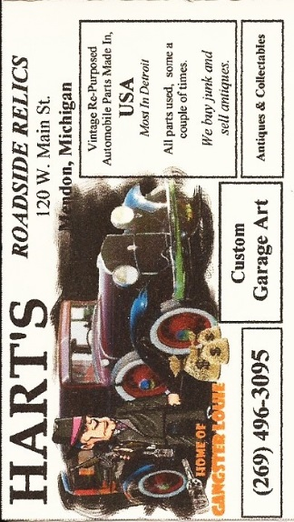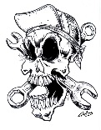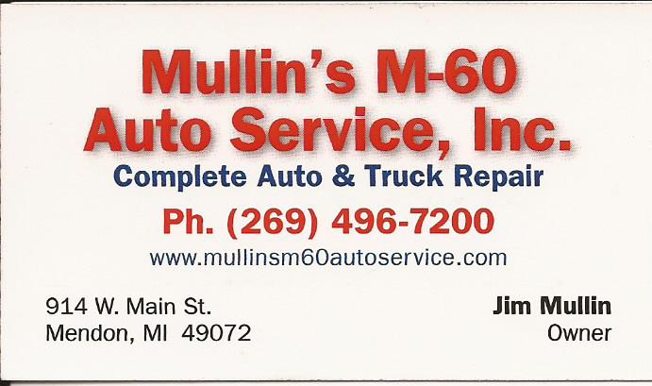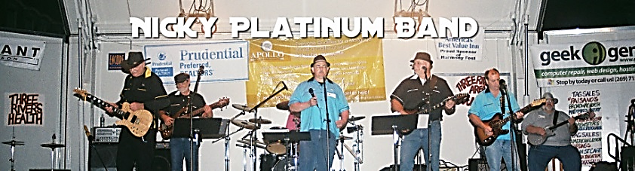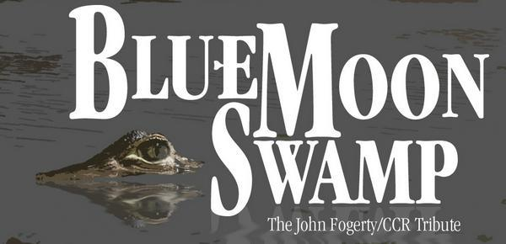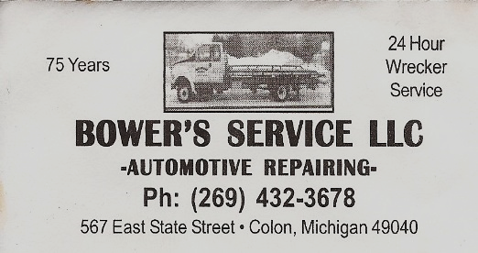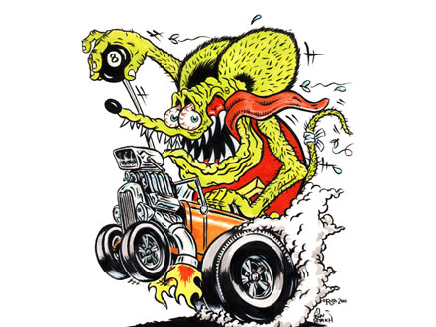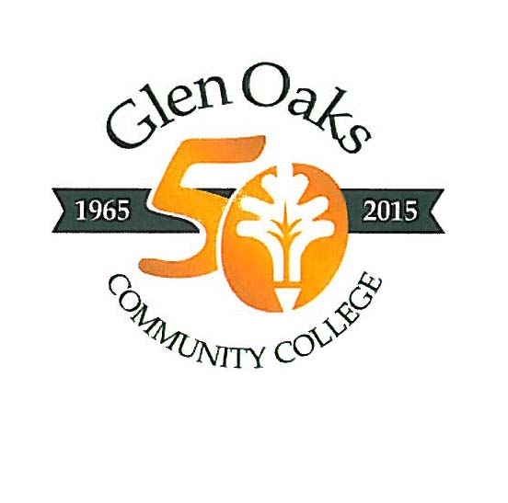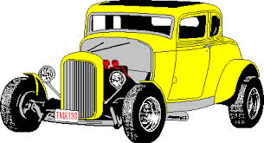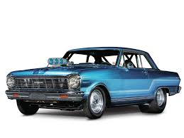

TOWING & RECOVERY

Dash Plaques, 50/50 Drawing, Door Prizes (*40 inch Flat Screen Drawn at 8:00 PM*)

Food & Beverages available on the grounds, Truck pulls by Fun Time Pullers.

Cruise Vehicles Use Franklin Street Gate. Must be Present to Win Door Prizes. For Additional Information Contact Kevin (269) 467-8935 or Jim (269) 496-3095

**THE 2ND ANNUAL GEAR HEAD GAMES**

**Trophy to Winner**

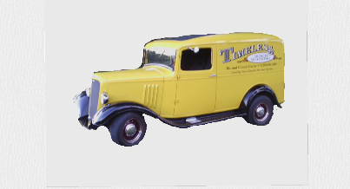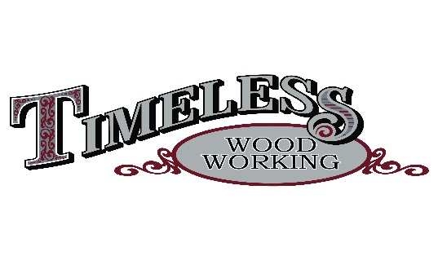

Ric & Connie Carter

(269) 496-7809

QUALITY THAT STANDS THE TEST OF TIME

**Dr. Joseph G. Smolarz DDS**

211 S Swan St, Colon, MI 49040  
(269) 432-3224

**40 INCH FLAT SCREEN SPONSOR**

Follow me to the cruise….

It’s Freeeee

**Saturday**

**June 13th, 2015**

**4 PM TO ?**

ON THE FAIRGROUNDS

316 E. CHARLOTTE ST.

CENTREVILLE, MICHIGAN 49032

Live entertainment starting at 5:30